**PROJECT**

**On**

**“TradeBot”**

**SUBMITTED TO**

J.C. Bose University of Science and Technology, YMCA

**IN THE PARTIAL FULFILLMENT OF THE REQUIREMENT FOR THE AWARD OF THE DEGREE OF**

**BACHELOR OF TECHNOLOGY**

**IN**

**COMPUTER SCIENCE AND ENGINEERING**



## Submitted To: Submitted By:

**Ms. Deepika Yadav Keshav Mishra (20CSE39)**

**Somay Kapoor (20CSE76)**

**Department of Computer Science & Engineering**

**(2022-23)**

# DECLARATION

I/We hereby declare that the project work entitled **“TradeBot”** submitted to J.C.Bose University Of Science and Technology, Faridabad, Haryana (India), is a record of an original work done by me/us under the guidance of

**“Ms. Deepika Yadav”** (Assistant Professor) in Computer Science and Engineering, ARAVALI COLLEGE OF ENGINEERING AND MANAGEMENT,

FARIDABAD, and this project work is submitted in the partial fulfillment of the requirements for the award of the degree of Bachelor of Technology in COMPUTER SCIENCE AND ENGINEERING.

# CERTIFICATE

Certified that this project report **“TradeBot”** is the bonafide work of “**Group ”** who carried out the project work under my supervision.

**SIGNATURE SIGNATURE**

HEAD OF THE DEPARTMENT

**Name: DESIGNATION(CSE)**

DEPARTMENT OF COMPUTER SCIENCE AND ENGINEERING ARAVALI COLLEGE OF ENGINEERING AND MANAGEMENT FARIDABAD – 121002

# ACKNOWLEDGEMENT

This project would not have taken shape, without the guidance provided by **“Ms. Deeepika Yadav”**, our Trainer who helped in the modules of our project and resolved all the technical as well as other problems related to the project and, for always providing us with a helping hand whenever we faced any bottlenecks, inspite of being quite busy with their hectic schedules.

We would also like to thank our project supervisor

**…………………………………** who gave us the opportunity and provided us all the academic and conceptual support for our project.

Above all we wish to express our heartfelt gratitude to ,

H.O.D, CSE DEPARTMENT whose support has greatly boosted our self- confidence and will go a long way on helping us to reach further milestones and greater heights.

# ABSTRACT

The main objective of this project is to design a voice based AI TradeBot.

Then, to workout all the necessary functions related to terms of Trading with all the necessary responses.

This project includes an implementation of an intelligent voice recognition for laptop OS where functionality on current existing applications on other platforms is compared. Until this day, there has not been any good alternative for laptop OS, so this project aims to implement a TradeBot for the laptop OS platform while describing the difficulties and challenges that lies in this task.

# Functionalities of this project include:

1. It Can invest in stocks.
2. It Can buy during Intradays.
3. It Can build Financial Portfolios.
4. It Can sell stocks.
5. It Can Do all necessary functions of Trading.
6. It Can Open Demat Accounts, invest in desiring firms.
7. It Can Give Perform Paper Trading and Back Testing as well.

# LIST OF FIGURES

It depicts the Number And Types of Libraries Involved:

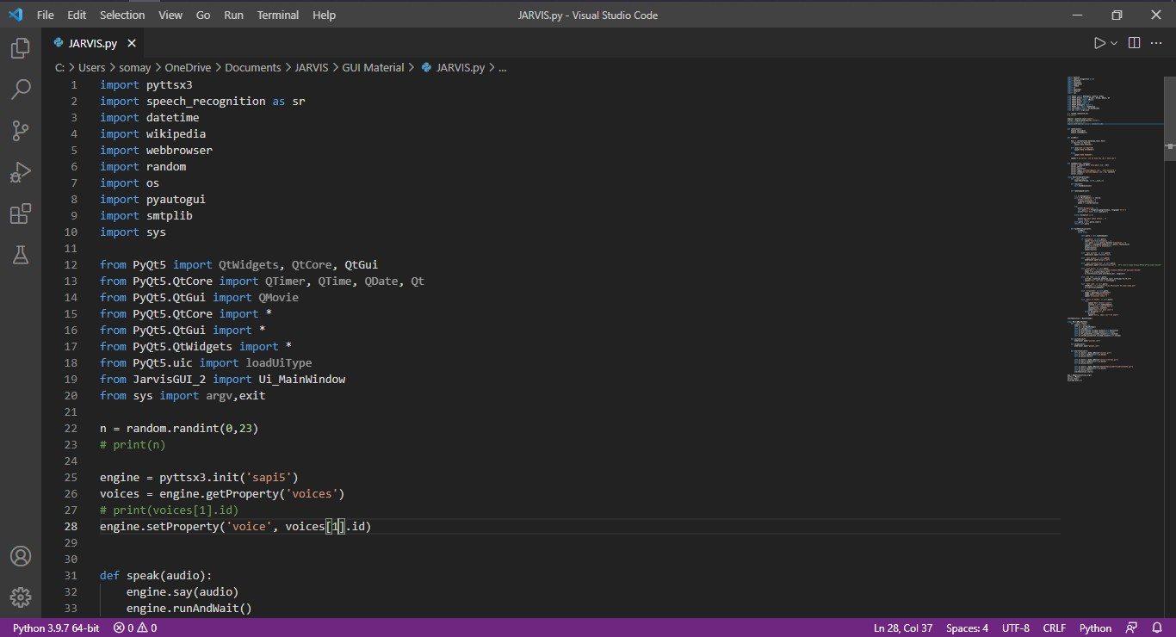

It depicts the Task Execution Commands for proper Functioning:

## TABLE OF CONTENTS

1. **INTRODUCTION**

𝖮 Problem Statement.......................………………………………………………

1.2 Objective of Proposed System…………………………………………............

* 1. Proposed System Architecture……………………………………………….…
  2. Scope of the Proposed System …………………………………………………

1.5 Feasibility Study………………………………………………………………..

1.5.1 Technical Feasibility…………………………………..........

1.5.2 Economic Feasibility……………………………………......

1.5.3 Financial Feasibility…………………………………...........

1.5.4 Safety Feasibility……………………………………............

## SYSTEM ANALYSIS

2.1 User Interface….......................................................................................................

2.2 H/W Requirements……………………………………………….........................

2.3 S/W Requirements………………………………………………..........................

2.4 Introduction of Tools………………………………………….............................

2.5 Requirements Specification……………………………………..........................

## SYSTEM DESIGN

3.1 System Functionality …………………………………………………………..

3.2 System Modules ………………………………………………………………...

3.3 Database Design……………………………………………………………….

3.4 Form Design, Outputs ……………………………………………....................

## TESTING & TEST RESULTS

4.1 Objective of Testing…………………………………………..............................

4.2 Step in Testing……………………………………………….................................

4.3 Level of Testing…………………………………………….................................

4.3.1 Unit Testing………………………………………………………....

4.3.2 System testing……………………………………………………..

4.3.3 Integration testing…………………………………………………

4.3.4 Acceptance Testing…………………………………..........................

4.4 Testing Strategy for Proposed System………………………………....

4.5 Testing Analysis…………………………………………..............................

## SYSTEM IMPLEMENTATION

5.1 System Coding ………………………………………………………………….

## SUMMARY AND CONCLUSIONS

6.1 Summary …………………………………………………………….

6.2 Limitations of the System…………………………………………………..

6.3 Improvements ……………………………………………………………..

6.4 Conclusion………………………………………………………………….

6.5 Future Scope …………………………………………………………………

**REFERENCES** ……………………………………………………………………

**APPENDIX**………………………………………………………………….

# INTRODUCTION

## TABLE OF CONTENTS

A TradeBot is an automated software program that interacts with humans. A TradeBot is merely a computer program that fundamentally simulates human conversations. A TradeBot that functions through AI and machine learning has an artificial neural network inspired by the neural nodes of the human brain. TradeBot are programs that can do talk like human conversations very easily. For example, Facebook has a machine learning TradeBot that creates a platform for companies to interact with their consumers through the Facebook Messenger application. In 2016, TradeBot became too popular on Messenger. By the consequences is noted that 2016 was the entire year of TradeBot. Thousands of TradeBot are invented on startups and used by the businesses to improve their customer service, keeping them hanging by a kind communication.

According to research, nowadays TradeBot are used to solve a number of business tasks across many industries like E-Commerce, Insurance, Banking, Healthcare, Finance, Legal, Telecom, Logistics, Retail, Auto, Leisure, Travel, Sports, Entertainment, Media and many others. Thus that was the moment to look at the TradeBot as a new technology in the communication field. Nowadays various companies are using TradeBot to answer quickly and efficiently some frequented asking questions from their own customers. AIML and LSA are used for creating TradeBot. Artificial Intelligence Markup Language (AIML) and Latent Semantic Analysis (LSA) are used for developing TradeBot, which are used to define general pattern-based queries. This pattern can also be used to give random responses for the same query in the TradeBot. LSA is a Latent Semantic Analysis technology in python, which is utilized to discover likenesses between words as vector representation. So that the unanswered queries by AIML will be viewed as a reply by LSA.

## SYSTEM ANALYSIS

**Platform**

* + **Operating System:** Windows 10 And Debian OS

## Technologies Used:

***Front End***: PyQt5

***Processing language***: Python

***API:*** ➢ Alpaca

Trality

# Software Requirements

1. Visual Studio
2. Console(EUDC Fonts)
3. Python IDE

# Hardware Requirements

* Minimum Processor I3 Required
* Hard Drive Minimum 500gb
* RAM Minimum 4GB
* Stable Internet Connection

## SYSTEM DESIGN

Systems design is the process of defining the architecture, components, modules, interfaces, and data for a given system to satisfy specified requirements. Systems design could be the application of various systems theory to product development. There is some overlap with the disciplines of systems analysis, systems architecture and system designing.

A TradeBot is a computer program, which is designed to simulate a conversation with human users using patterns, especially over the internet. They are our online assistants that offer different services through chatting over the internet. To build artificial intelligence TradeBot through Python, you will require an AIML package (Artificial Intelligence Markup Language). First, we need to create a standard startup file without any pattern and load aiml in the kernel. Add random response patterns that would make dialogue interesting. Now, to code your own AIML files, look for some files which are available beforehand. For example, browse all among files from the Alice Bot website. The startup file we will be creating will act as a separate entity.

As a result of which, we will have more AIML files without a source code modification. The program will start running when there are enough AIML files for loading. This was an introduction to how to make AI TradeBot using Python. Now, let’s proceed further and see which particular library can be implemented for building an AI TradeBot.

## TESTING & TEST RESULTS

**•RESPONSE TIME TEST ID:** T1 TEST PRIORITY: HIGH TEST OBJECTIVE: TO MAKE SURE THAT THE SYSTEM RESPOND BACK TIME IS EFFICIENT. DESCRIPTION: TIME IS VERY CRITICAL IN A VOICE BASED SYSTEM. AS WE ARE

NOT TYPING INPUTS, WE ARE SPEAKING THEM. THE SYSTEM MUST ALSO REPLY IN A MOMENT. USER MUST GET INSTANT RESPONSE OF THE QUERY MADE.

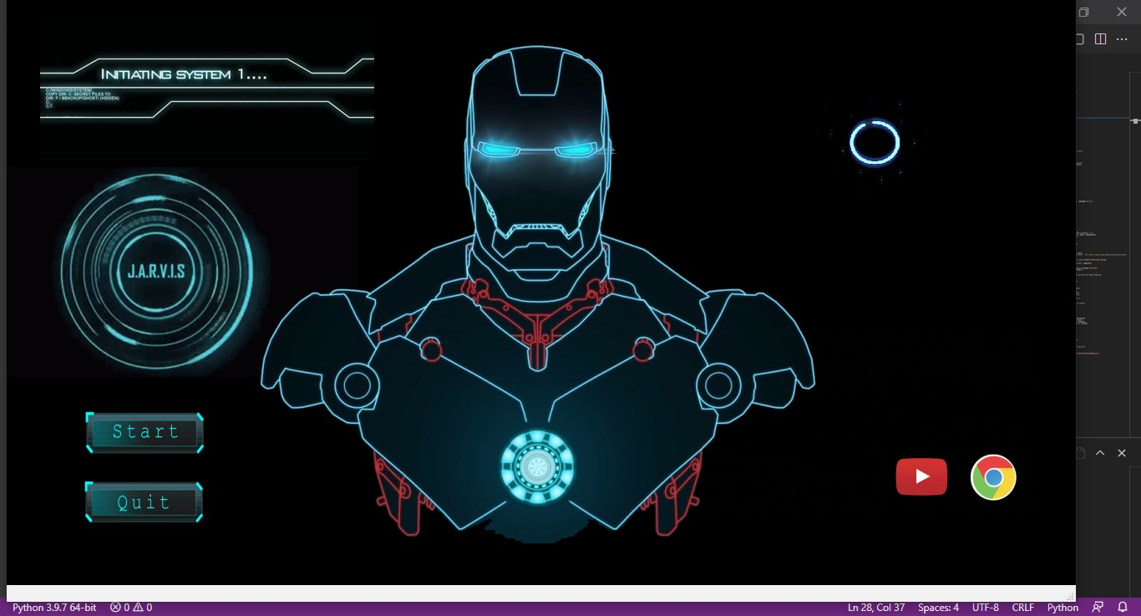

## ACCURACY TEST ID: T2 TEST PRIORITY: HIGH TEST OBJECTIVE:

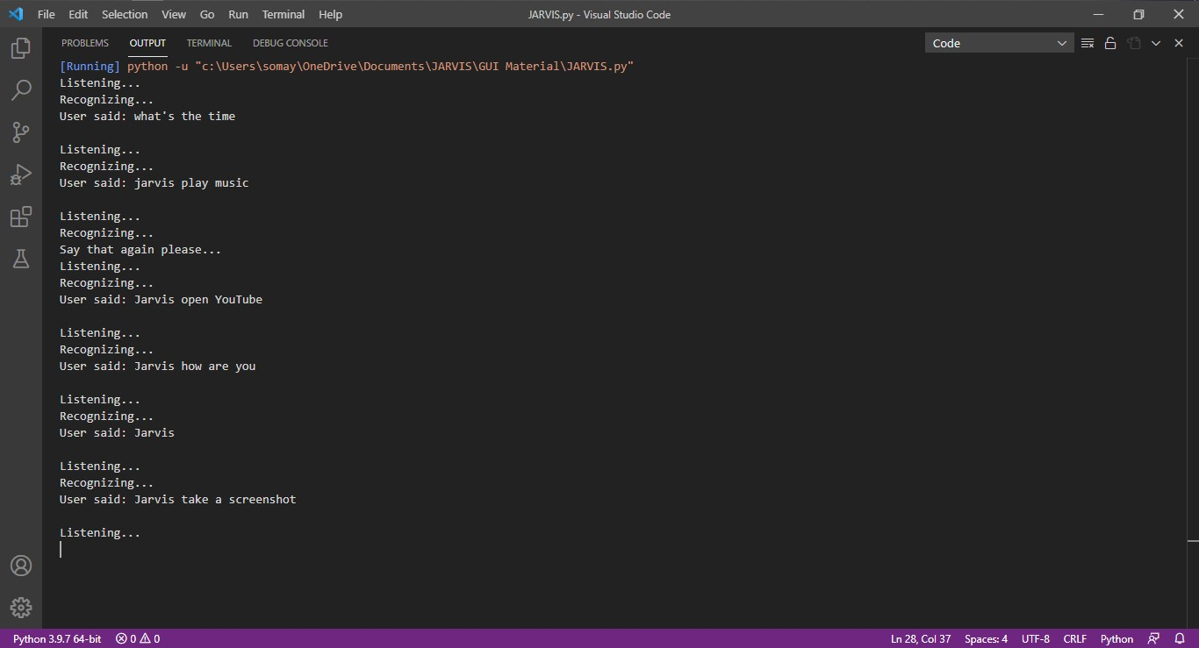TO ASSURE THAT ANSWERS RETRIEVED BY SYSTEM ARE ACCURATE AS PER GATHERED DATA. DESCRIPTION: A VIRTUAL ASSISTANT SYSTEM IS MAINLY USED TO GET PRECISE ANSWERS TO ANY QUESTION ASKED. GETTING ANSWER IN A MOMENT IS OF NO USE IF THE ANSWER IS NOT CORRECT. ACCURACY IS OF UTMOST IMPORTANCE IN A VIRTUAL ASSISTANT SYSTEM.

## APPROXIMATION TEST ID: T3 TEST PRIORITY: MODERATE TEST

**OBJECTIVE:** TO CHECK APPROXIMATE ANSWERS ABOUT CALCULATIONS. DESCRIPTION: THERE ARE TIMES WHEN MATHEMATICAL CALCULATION REQUIRES APPROXIMATE VALUE. FOR EXAMPLE, IF SOMEONE ASKS FOR VALUE

OF PI THE SYSTEM MUST RESPOND WITH APPROXIMATE VALUE AND NOT THE ACCURATE VALUE. GETTING EXACT VALUE IN SUCH CASES IS UNDESIRABLE.

## SYSTEM IMPLEMENTATION

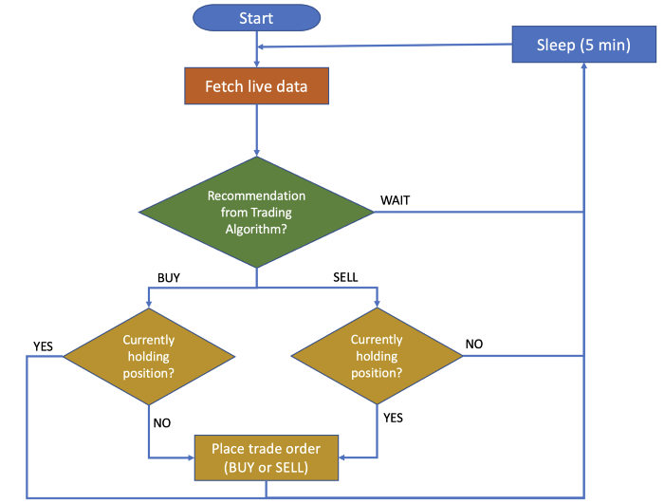

1. **SUMMARY AND CONCLUSIONS**

In this project, we have introduced a TradeBot that is able to interact with users. This TradeBot can answer queries in the textual user input. For this purpose, AIML with program-o has been used. The TradeBot can answer only those questions which he has the answer in its AIML Dataset. So, to increase the knowledge of the TradeBot, we can add the API s of Wikipedia, Weather Forecasting Department, Sports, News, Government and a lot more. In such cases, the user will be able to talk and interact with the TradeBot in any kind of domain.

Using API s like Weather, Sports, News and Government Services, the TradeBot will be able to answer the questions outside of its datasets and which are currently happening in the real world. The next step towards building TradeBot involves helping people to facilitate their work and interact with computers using natural language or using their set of rules. Future Such TradeBot, backed by machine-learning technology, will be able to remember past conversations and learn from them to answer new ones. The challenge would be conversing with the various multiple bot users and multiple users. As future work, we can make a TradeBot that is based on AIML and LSA. This technology will enable a client to interact with a TradeBot in a more natural fashion. We can enhance the discussion by including and changing patterns and templates for general client queries using AIML and the right response are given more often than LSA.

## FUTURE PERSPECTIVE

There are limitations to what has been currently achieved with TradeBot. The limitations of data processing and retrieval are hindering TradeBot to reach their full potential. It is not that we lack the computational processing power to do so. However, there is a limitation on “How” we do it. One of the biggest examples is the retail customer market. Retail customers are primarily interested in interacting with humans because of nature of their needs.

# REFERENCES

1. Bayan Abu Shawar and Eric Atwell, 2007 “TradeBot: Are they Really Useful?”

1. LDV Forum - GLDV Journal for Computational Linguistics and Language Technology.
2. http://www.ldv-forum.org/2007_Heft1/Bayan_AbuShawar _and_Eric_Atwell.pdf
3. Bringing TradeBot into education: Towards natural language negotiation of open learner models. Know.- Based Syst. 20, 2 (Mar. 2007), 177-185.
4. Intelligent Tutoring Systems: Prospects for Guided Practice and Efficient Learning. Whitepaper for the Army's Science of Learning Workshop, Hampton, VA. Aug 1-3, 2006.
5. https://en.wikipedia.org/wiki/Chatterbot
6. ALICE. 2002. A.L.I.C.E AI Foundation, <http://www.alicebot.org/>

1. Kumar, M Naveen, PC Linga Chandar, A Venkatesh Prasad, and K Sumangali (2016). “Android based educational TradeBot for visually impaired people”. In: International Conference on Computational Intelligence and Computing Research (ICCIC), 2016 IEEE. IEEE, pp. 1–4.
2. Ranoliya, Bhavika R, Nidhi Raghuwanshi, and Sanjay Singh (2017). “TradeBot for University Related FAQs”. In: 2017 International Conference on Advances in Computing, Communications and Informatics (ICACCI). Udupi, pp. 1525–1530.